User Interface Specification：

According to the software function design, the user will go through the following steps：

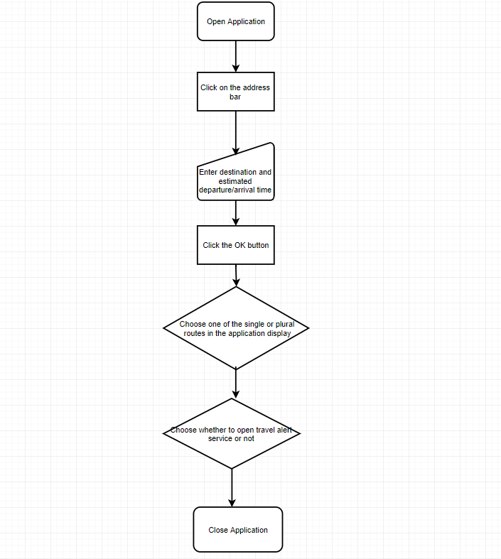

|  |  |  |  |
| --- | --- | --- | --- |
| Operation | | Example | Remarks |
| Open Application | |  |  |
| Click on the address bar | |  |  |
| Enter destination | |  |  |
| Enter departure/arrival time | |  | This function will be added to the navigation software. |
| Click the OK button | |  |  |
| Choose one of the single or plural routes in the application display | |  | On this page, the departure and arrival times are expected to be added to the options for reference. |
| Choose whether to open travel alert service or not | |  | This function is designed to avoid travel time forgetting caused by long time elapse. |
| Close Application |  | |  |